Roughness statistics of prismatic ice facets

Authors: Roesel, Harrison, Roeselova, Neshyba

Abstract:

- Introduction

Why this is important and interesting: remote sensing, crystal growth, cirrus clouds, radiative forcing.

- Methods

  - VPSEM protocols.
  - 3-d surface acquisition.
  - Roughness parameter r, distribution functions

- Results and analysis

Figure 1 shows a crystal grown in the VPSEM. Definition of z- and x-axes. Definition of prismatic facet.

Figure 2 shows profiles of surface height and roughness parameter for two sets of conditions, 50 Pa and 25 Pa. Commentary … Which seems rougher? Which has bigger spatial wavelength?

Figure 3 shows normalized probability densities of crystals. Commentary. Discussion of uncertainty.

Limitations of this work … time dependents … how well do we know whether we’re at equilibrium.

- Discussion

Neshyba et al (2013) showed just four crystals, one profile each, at prismatic facet boundaries. They calculated Weibull parameters, but these were statistically uncertain. This work improves on their methodology by using the 3d software (which also obviates the need to use prismatic facet boundaries). The result is much more statistically sound conclusions.

Baran et al talked about Weibull parameters of cirrus clouds in a certain range … this work relates to that in the sense of …

What’s the physical significance of fitting to Weibull? Weibull distributions are 2-parameter fits.

- Conclusions

- Statistically sound calculation of the roughness probability distribution.
- Inferred Weibull statistics.
- Documented trends in roughness with temperature.

Figure Captions

Figure 1. VPSEM micrograph of an ice crystal at 25 Pa and -40°C.

Figure 2. Profiles of roughness.

Figure 3. Probability densities.

Figure 1.

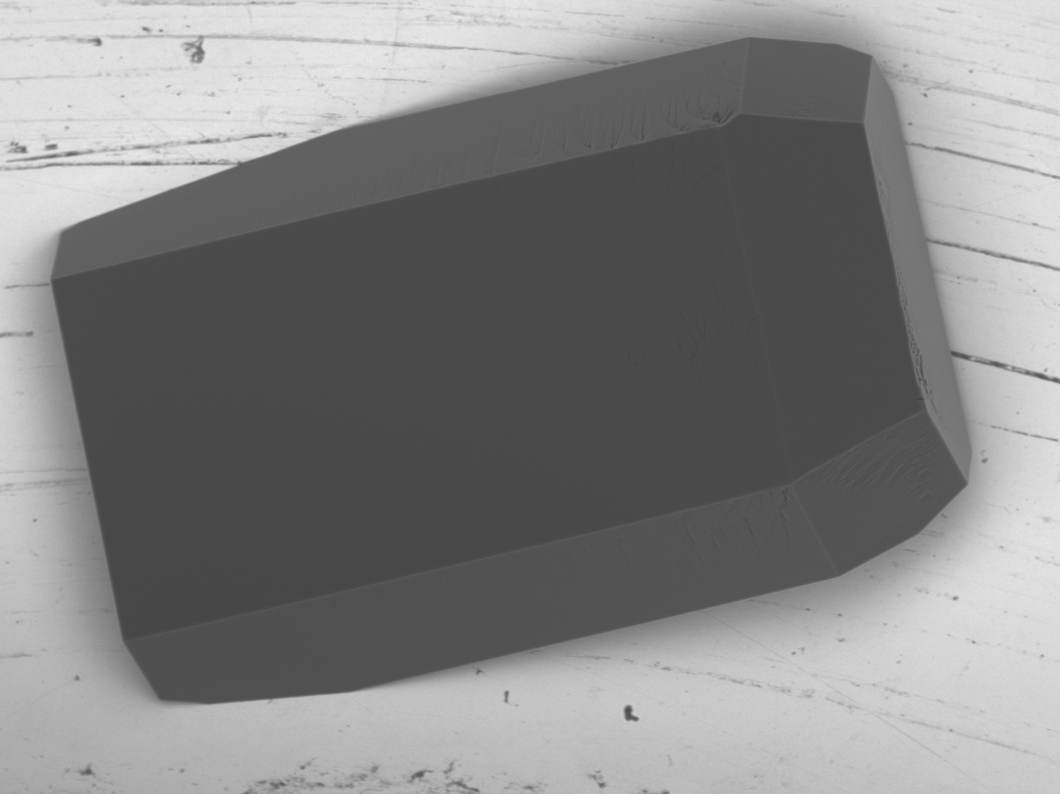

Figure 2.

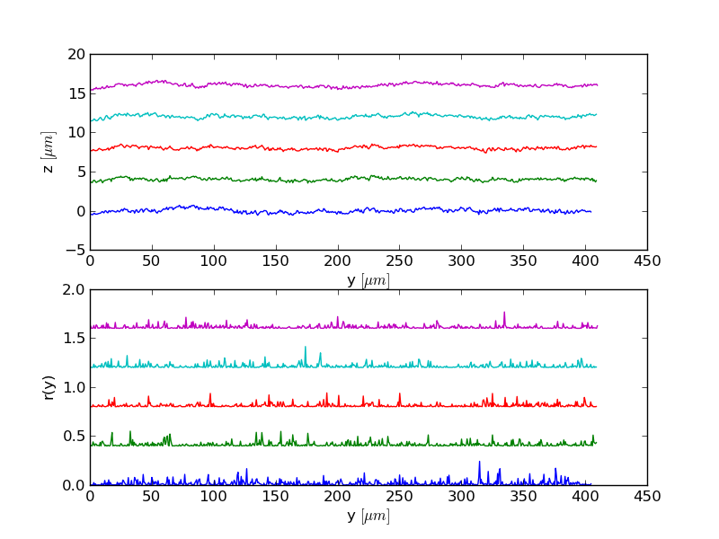 | 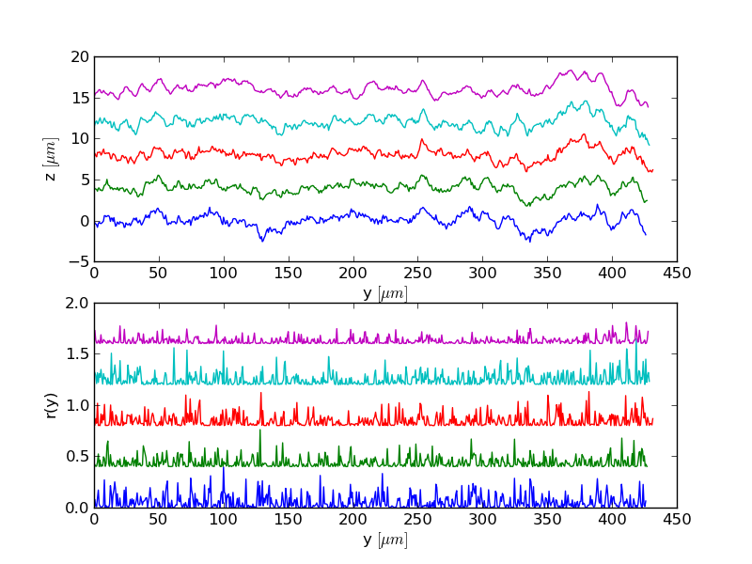

Figure 3.

